B.N.M. Institute of Technology
2th Main, 27th Cross, Banashankari II Stage, Bangalore 560 070,
Department of Computer Science and Engineering
2013-2014
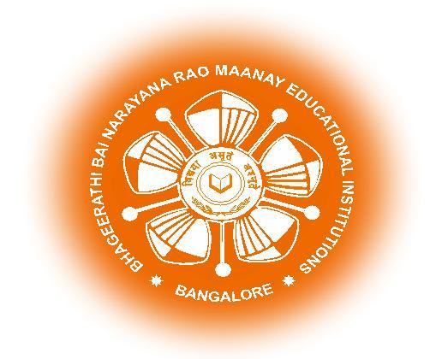

Vidyaya Amrutham Ashnuthe

CERTIFICATE

This is to certify that the project work entitled “A light weight randomized low sampling compression technique verified by GI with merits over CR and IT reconstruction schemes” has been successfully completed and is a bona fide work carried out by
1. Abhishek Sharma R 1BG10CS003
2. Chaitra Suresh 1BG10CS025
3. Chandan S 1BG10CS026
in partial fulfillment for the award of Bachelor of Engineering in Computer Science & Engineering degree of the Visvesvaraya Technological University, Belgaum during the year 2014. It is certified that all corrections / suggestions indicated for the internal assessment have been incorporated in the report deposited in the departmental library. The report has been approved as it satisfies the academic requirements in respect of project work prescribed for the said degree.

Smt. Savitha G Dr. B.G. Prasad Dr. M.S. Suresh
Project guide Prof and HOD Principal

Name of the examiner | Signature
1.
2.

